Figures:

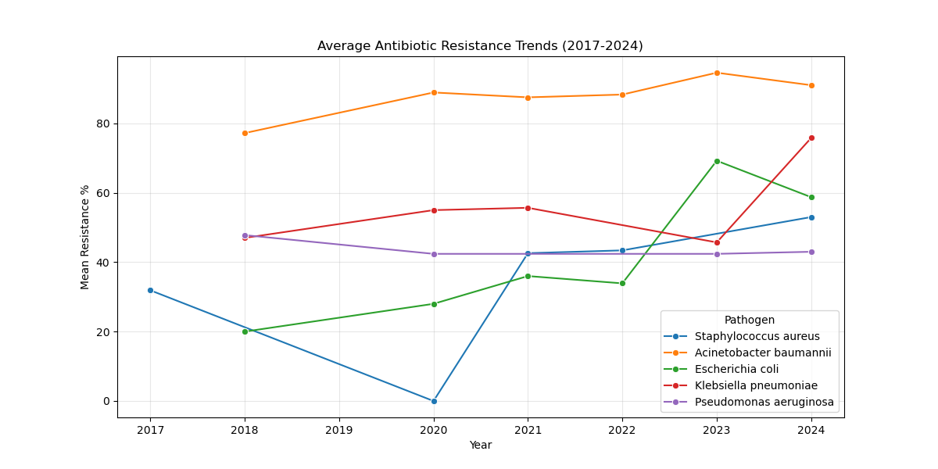
Figure 1: Longitudinal trends of antimicrobial resistance in priority pathogens across 21 ICMR-AMRSN Regional Centers (2017-2024).

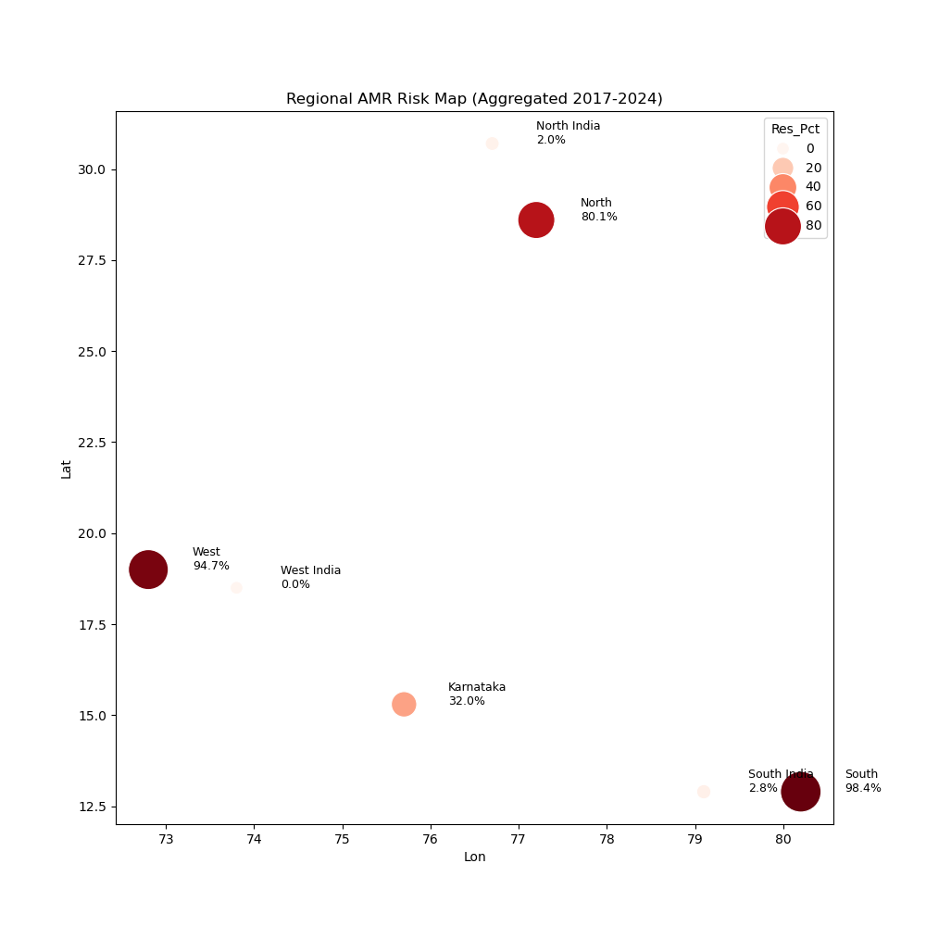
Figure 2: Heatmap of resistance hotspots across Indian Regional Centers. Darker shades indicate higher carbapenem resistance prevalence.

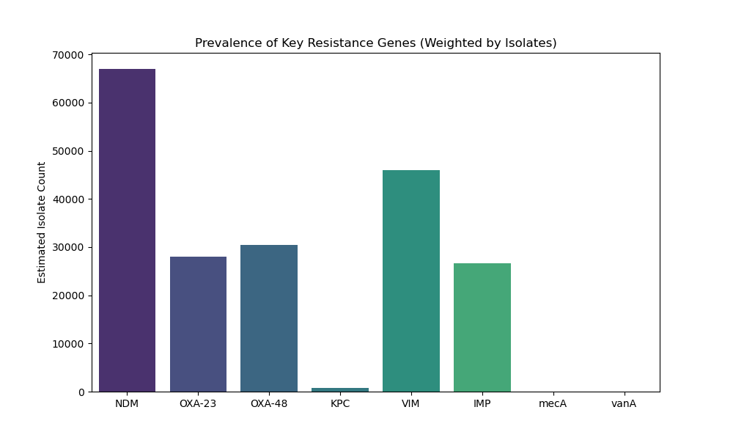
Figure 3: Prevalence of key resistance genes and mechanisms among carbapenem-resistant isolates in India.

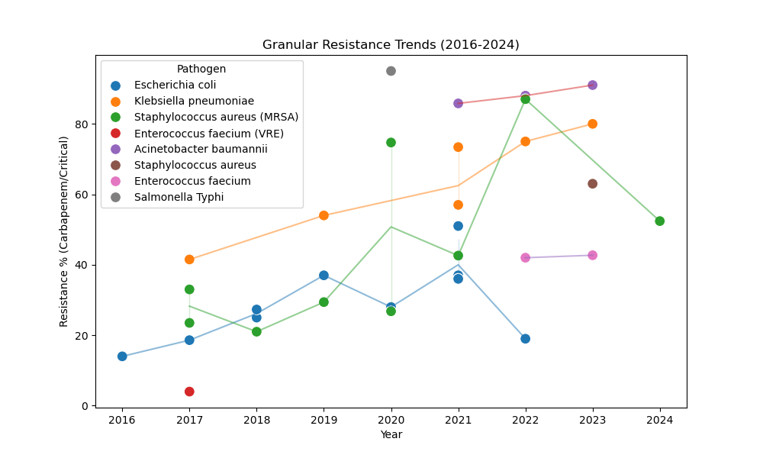
Figure 4: Machine Learning forecast (dashed line) versus actual observation (solid line) for key sentinel centers.
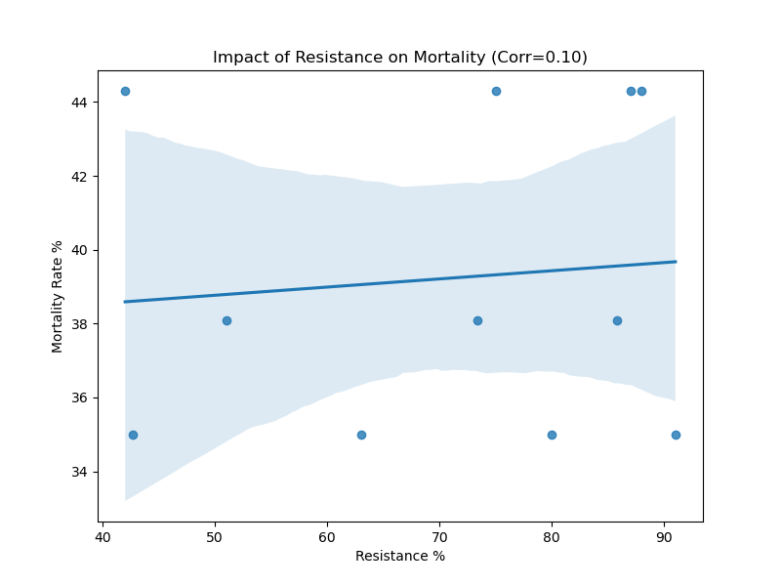
Figure 5: Correlation between Carbapenem Resistance (%) and aggregate ICU Mortality Rate at the center level.

